Chapter 7, Problem 78.

The switch in Fig. 7.142 moves from position a to b at t = 0. Use PSpice to find i(t) for t > 0.

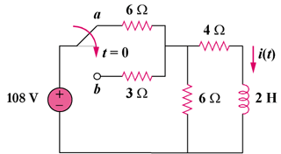

Figure 7.142
For Prob. 7.78.

